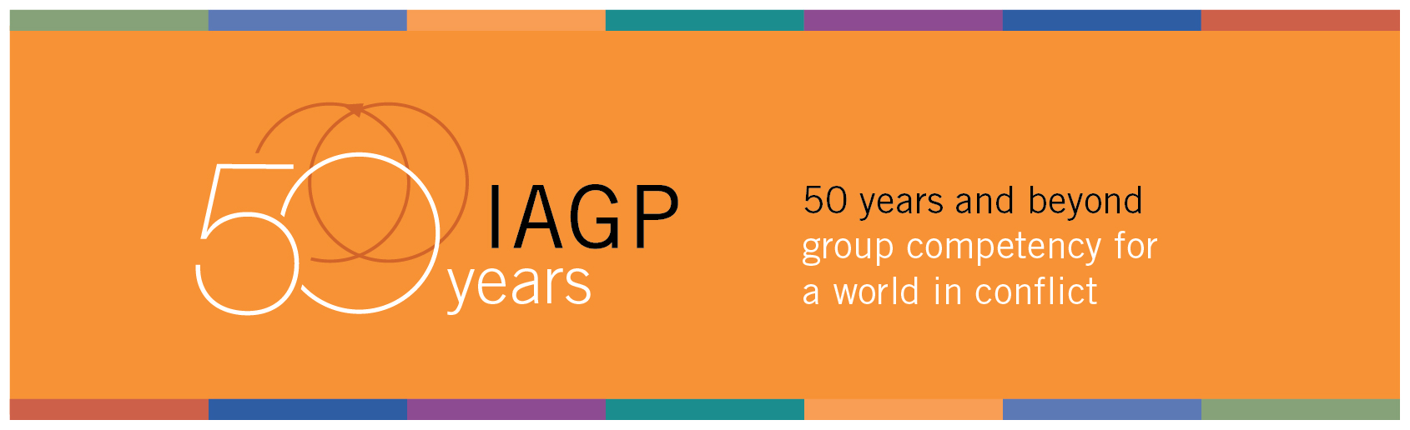Psychological First Aid in Natural Disaster Traumas
22 June 2024
IAGP Social and Collective Traumas Committee Document
A document prepared to provide a road map support for emergency interventions in natural traumas

A wide range of theoretical models, interventions, and strategies can be employed in delivering mental health services following natural disasters. These theoretical models span from crisis intervention to critical incident stress management and psychological first aid. This brief article provides a concise summary of what professionals should do immediately following mass traumas. The goal is to equip them with the ability to assume the role of providing rapid and effective psychological first aid.
For those of us who are knowledgeable about group intervention methods and experts in these areas, the following basic principles should be carefully considered in psychological first aid right after the trauma.
- Investigate the needs of groups exposed to mass trauma for their survival first, and if any communication is to be made with them, please only ask about their needs.
- Be aware of and assess people who are particularly at risk due to the severity of their response or previous conditions, activate specific management for them, possibly with local resources.
- Although there are some psychotherapy interventions designed for early intervention Generally do not provide any psychotherapeutic intervention to those exposed to mass trauma in the initial stage.
- It is a wrong strategy to try to empathize with or express understanding of the experiences of those affected by mass trauma. It is impossible for us to fully understand what they are going through. Never say "I understand you".
- Individuals affected by mass trauma are mostly right in all matters. In order to create a space for survivors to express their feelings in this stage, it is important to validate their subjective experience.
- Mental health professionals should quickly alert relevant official and civil organizations to prevent possible emerging social problems.
- Ensure that non-experts do not provide psychological first aid in the field by providing all necessary information.
- Volunteers who wish to work in the field can be carefully chosen and assessed, the same for any translators; they should be trained in groups or provided with information through various media channels.
- Teams providing vital aid should be trained quickly on how to communicate with traumatized individuals, and the issues mentioned here should be thoroughly explained.
- If possible, provide consultancy on the messages to be given by the leaders of the countries affected by trauma through relevant mental health associations.
- Ensuring that the large group affected by trauma does not feel alone is as important as the aid to be sent.
- Psychotherapists who will provide therapeutic assistance should begin training on trauma interventions right after the trauma, so that they can ready after psychological first aid processes.
- Diagnosing post-traumatic stress disorder should be carefully considered within two to three months after the mass trauma. Attention should be paid to the issue of Acute Stress Disorder during this period.
- Do not neglect self-care; provide specific procedures and resources. Overload puts self-care and the quality of the support offered at risk. The helpers will also need support due to vicarious trauma risks and they often also need to be made aware of this need.

- Support and promote the local community as a fundamental part of the support, as much as possible. This aids in the appropriateness of the intervention, ensures sustainability in the medium and long term, and acts as a protective factor.

- Know and take into account any cultural differences that may arise in the field. Always intervene with cultural sensitivity.
- Collect the data and get in touch with other qualified organizations and agencies. It is useful whenever possible to establish the basis for organizing effective interventions, even in confusing situations, reducing overlaps and blind spots. Value the collection of feedback and impressions in the field to dynamically adapt interventions to actual needs.
- Prepare and establish procedures for communicating bad news with the trauma survivors and the rest.
- Finally, while all these aids are ongoing, how to provide psychological assistance to small and large groups should be planned both online and in person. The groups to be provided after psychological first aid should be target-focused and limited in time. Groups in the early phase of disaster response be contained/structured but also non-directive, allowing participants choice in their level of participation

For more and different guidelines this web page could be helpfull: https://www.mhpssmsp.org/en/activity/relevant-guidelines-standards-and-tools-support-implementation-1#page-1

Special thanks to Scott Giacomucci for his generous contribution.

Deniz Altınay and Nicola Policicchio
Co-Chair of the Social and Collective Traumas Committee

